Touchstones Monthly Themes for 2020-2021

Annual Theme Deepening Connections
Contemporary society is plagued by isolation, loneliness, and despair. While social media facilitates connections and networking, it tends to be superficial. People do not have deep relationships that foster connection and support. In times of crisis, too many people have no one to turn to. Our congregations must strive to nurture deepen connections among members, newcomers, and strangers.

September 2020 Worth & Dignity

Through much of history, the value of the individual has been negligible. This has led to disastrous outcomes. Our assertion of the inherent worth and dignity of every person leads to a very different calculus in how we treat each other, including those with whom we strongly disagree, the stranger, and even our enemy. This assertion can evoke mutual respect and compassion.
Photo, Universal Declaration of Human Rights, Article 1, by Val Kerry, May 23, 2008, (CC BY 2.0), https://www.flickr.com/photos/artmakesmesmile/2516476754

October 2020 Emotional Intelligence

While IQ has long been valued, intelligence alone is not sufficient for success. Equally important is EQ or emotional intelligence with its focus on self-awareness, self-regulation, motivation, empathy, and social skill. These emotional competencies are not innate, but they can be learned. Through them, thinking and feeling are employed together in life-affirming ways that influence all of our interactions.
Photo by Tengyart on Unsplash

November 2020 Spirituality
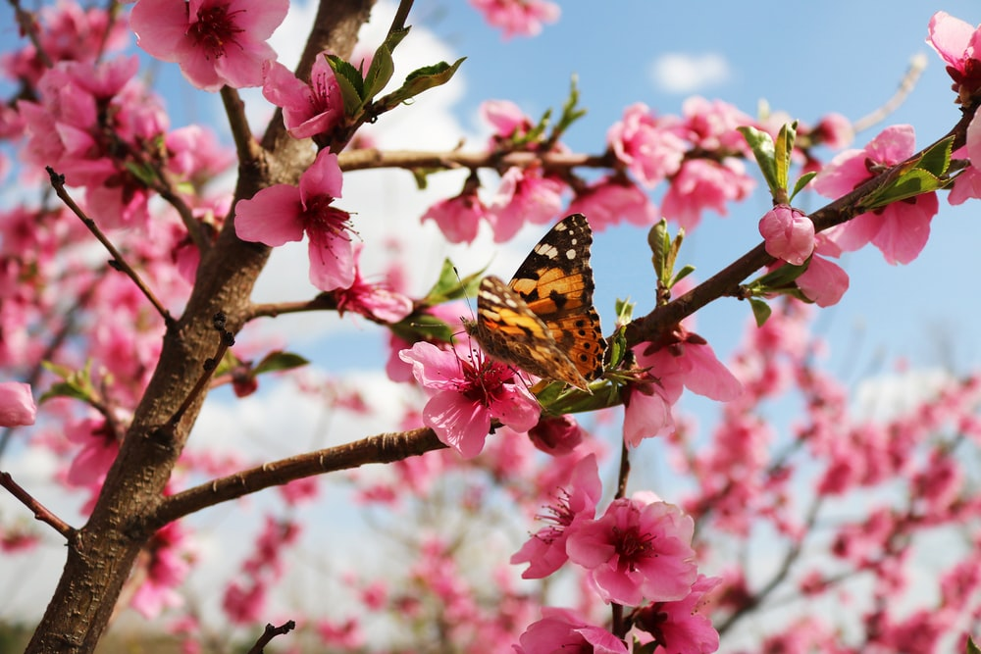
Spirituality involves a heightened sense of connection with the deepest part of oneself, with others, and with a transcendent reality, however that is understood. This relates to a desire for wholeness. It can be cultivated and deepened through a variety of spiritual practices. Spirituality has to do with the cultivation of the inner life that we might live with more authenticity, integrity, humility, and compassion.
Photo by Seyedeh Hamideh Kazemi on Unsplash

December 2020 Kindness
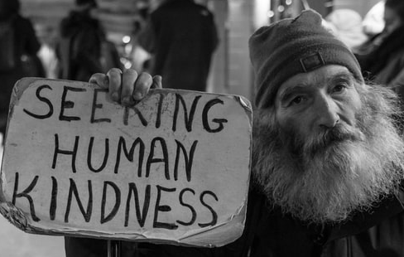
Ian MacLaren wrote, “Be kind; everyone you meet is fighting a hard battle.” Kindness is considered a virtue, a moral obligation, the currency of compassion, an act of solidarity, radical hospitality, communion, a lifeline, a balm in Gilead, and much more. Human civilization would not long survive without it. In fact, it is kindness that civilizes us and those with whom we interact.
Photo by Matt Collamer on Unsplash/

January 2021 Consolation / Desolation

Consolation and desolation are conditions of the human experience. Desolation arises out of loss, grief, failure, fear, sadness, loneliness, and more that have the capacity to destroy us. Some of these may be impersonal, but consolation is always personal. It comes as a profound gift from another: compassion, a willingness to listen without judgement, a kind word, a hug, and other acts of kindness and care.
Photo by Kat J on Unsplash

February 2021 Mercy

The prophet Micah counseled us, “To act justly, to love mercy, and to walk humbly with our God.” These qualities are universal and transformative. Justice and humility are important, but it is the love of mercy that is crucial. To love mercy is to understand how very important it is in human relations. Mercy is a grace because it is not deserved. It allows a person to return to life with dignity.
Photo by Priscilla Du Preez on Unsplash

March 2021 Respect

Respect is the way that we affirm another’s worth & dignity. UU minister Tom Owen-Towle has suggested that respect is more important than love. The word respect comes from a Latin root that means “to look back, to regard.” It reminds us that when we look with the hard eyes of judgment, we would be wise to look again with the soft eyes of respect that we might truly see beneath superficialities.
Photo by Max Böhme on Unsplash

April 2021 Mindfulness


Mindfulness is the quality and practice that overcomes our fragmentation so that we can experience wholeness. Mindfulness is the call to pay attention. M. Scott Peck said that, “The principal form of love is attention.” Being mindful is paying attention to our self, others, and the world. Mindfulness requires skill, but its practice is transformative of our self and our relationships.
Photo by Chelsea Gates on Unsplash

May 2021 Acceptance


Acceptance is key to our third principle: acceptance of one another; not superficially, but in deep ways. The invitation of acceptance is mutual. It confers the gift of belonging in community. It communicates “you matter.” This capacity is based on the premise of self-acceptance, to love who you are. Self-acceptance, flaws and all, is the bridge to accepting another.
Photo by Sharon McCutcheon on Unsplash

June 2021 Care of the Soul

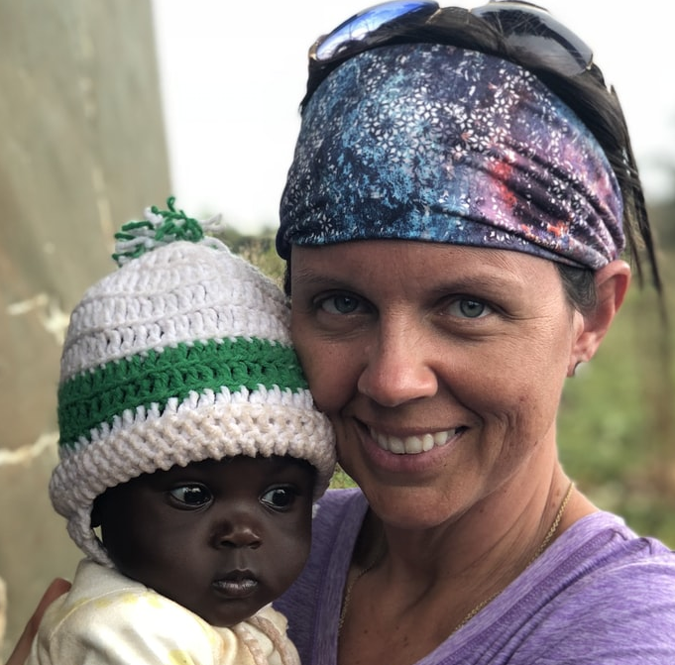
Rev. Nancy Shaffer asked, “How shall we mend you, sweet Soul? …Come sit. Come tell me.” The soul is understood as our essence, as the core of our being. It is sturdy, but not invincible. Subject to the tragedies that touch our lives, the fabric of the soul can be torn. Shaffer concluded, “We will mend you with pieces of your own sweet self, sweet Soul.” The care of the soul is important work for it is self-care.
Photo by Zach Vessels on Unsplash


July 2021 Journey
Lynn Hough wrote, “life is a journey and not a destination.” Life is a series of waystations woven together by our journey. No straight line. A meander with dead-ends, amazing vistas, dense forests, cool waters, treasured companions, and mountains, always mountains. It is getting lost and being found again. It is the present moment and distant memory. We use the journey to discover our self.
Photo by Joshua Sortino on Unsplash


August 2021 Communion

The Latin root of communion means “fellowship, mutual participation, or sharing.” The word implies a deep connection, which is the outcome of participating in community in meaningful ways. It is a process of giving and receiving, the work of heart and hands, an invitation to friend and stranger alike. No altar is required, just a welcome table with room for one more, always one more.
Photo by Tim Marshall on Unsplash

